

**TECHNICAL UNIVERSITY OF MOLDOVA**

**FACULTY OF COMPUTERS, INFORMATICS AND MICROELECTRONICS**

**DEPARTMENT OF SOFTWARE ENGINEERING AND AUTOMATICS**

**Laboratory Work No. 6**

**Finite Automata**

**Student: Pogorevici Daniel FAF-202**

**Teacher: univ.lecturer Moraru Dumitru**

**Chisinau 2023**

**TASK OF THE LABORATORY WORK**

To implement Finite Automata, an application will be developed as follows:

1. Finite Automaton Design for Elevator application in a building with at least 8 floors.
2. Finite Automaton Design for Traffic Light application, with the use of three colors of the traffic light being mandatory.

**PROGRESS OF THE WORK**

1. **Description of the main functions used to perform the task**

To do the laboratory work, I connected the **8** buttons to an *Arduino MEGA 2560* for the Elevator simulation task.

I also connected the one button and **3** LEDs of each colour (Red, Yellow and Green) to an Arduino.

1. **Bloc diagram of program**

Firstly, we set up the transitions of the elevator States:

**Figure 1** Source code snippet for the elevator transitions

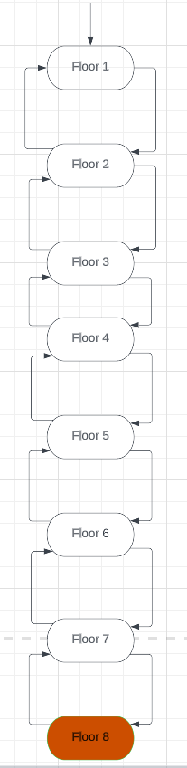

**Figure 2** Finite Automata for the Elevator

We also set up the states for the Semaphore:

**Figure 3** Source code snippet for the semaphore states

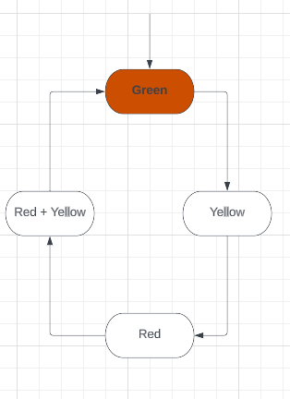

**Figure 4** Finite automata for the Semaphore

1. **Simulated electrical schematic**

**Figure 5** Simulated electrical schematic for the Elevator

**Figure 6** Simulated electrical schematic for the Semaphore

**CONCLUSIONS**

In conclusion, implementing finite automata is a valuable approach to enhance the functionality and safety of elevators and semaphores. By utilizing state machines to model the behavior of these systems, we can ensure their predictable and reliable operation.

Finite automata offer a structured framework to depict various aspects of elevator functionality, such as car movement, door operations, and control panel interactions. This leads to improved efficiency and safety by preventing unintended movements and reducing the risk of collisions. Similarly, in the case of semaphores, finite automata can effectively govern traffic flow, ensuring the safe navigation of vehicles and pedestrians through intersections.

By minimizing the potential for accidents and managing traffic congestion, these state machines contribute to enhanced road safety.

Overall, the utilization of finite automata serves as a powerful tool to enhance the functionality and safety of intricate systems like elevators and semaphores. By carefully designing and implementing state machines, we can ensure the reliable and predictable operation of these systems, benefiting both operators and users.